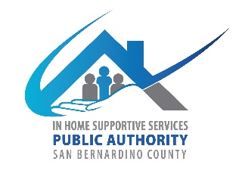
San Bernardino County
In-Home Supportive Services (IHSS) Advisory Committee
784 E Hospitality Lane
San Bernardino CA 92415
April 2, 2025, WEDNESDAY
9:30 AM to 12:30 PM
IHSS Conference Room A

- Call to Order

- Approve Minutes from February 5, 2025

- IHSS Advisory Committee (AC) Introductions and Member Reports

- Public Comment on Non-Agenda Items
Please note: Public Comment on agenda items will be heard during that item. Public comment is limited to 5 minutes per speaker. Submit Public Comment card to Chair.

IHSS Public Authority Report -- Myette Christian/Melissa Cardenas

Department of Aging and Adult Services-Public Guardian Report—Brenda Serna

- Old Business
  - AC Procedures Review
  - AC Bylaws Finalized
  - Vendor Table Coverage for Training Summit

- New Business
  - AC Board Member’s name and title for PA website
    - Should designated contact info be listed?
  - Fiscal Report-Fiscal year (July 1, 2024-June 30, 2025)
  - Recruitment
    - Review new applications
    - Members are encouraged to invite a guest (IHSS client or caregiver) to the next meeting

- Discussion/Resources
  - California In-Home Supportive Services Consumer Alliance (CICA) Report

- Adjournment

