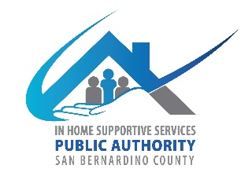
San Bernardino County
In-Home Supportive Services (IHSS) Advisory Committee
784 E Hospitality Lane
San Bernardino CA 92415
June 4, 2025, WEDNESDAY
9:30 AM to 12:30 PM
IHSS Conference Room A

- Call to Order

- Approve Minutes from April 2, 2025

- IHSS Advisory Committee (AC) Introductions and Member Reports

- Public Comment on Non-Agenda Items
Please note: Public Comment on agenda items will be heard during that item. Public comment is limited to 5 minutes per speaker. Submit Public Comment card to Chair.

IHSS Public Authority Report -- Myette Christian/Melissa Cardenas

Department of Aging and Adult Services-Public Guardian Report—Brenda Serna

- Old Business
  - AC Procedures and Bylaws Final Review
  - AC Board Member’s name, title, and group photo for PA website

- New Business
  - Fiscal Report-Fiscal year (July 1, 2024-June 30, 2025)
  - Recruitment
    - Review new applications
    - Members are encouraged to invite a guest (IHSS client or caregiver) to the next meeting

- Discussion/Resources
  - Summary of Past Events
    - Adult Protective Services (APS) Multi-Disciplinary Team (MDT) Conference, IHSS PA Training Summit, and CICA lunch
  - California In-Home Supportive Services Consumer Alliance (CICA) Report
    - CICA Membership Renewal for 25-26 Fiscal Year

- Adjournment

