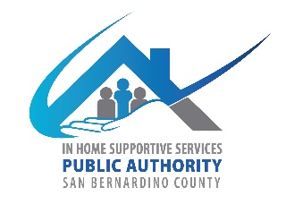
San Bernardino County
IHSS Advisory Committee
784 E Hospitality Lane
San Bernardino CA 92415
May 3, 2023, WEDNESDAY
9:00 AM to 12:00 PM
IHSS Conference Room A or Teleconference

- Call to Order

- Approve Minutes from March 1, 2023

- IHSS Advisory Committee Introductions and Member Reports

- Public Comment on Non-Agenda Items
Please note: Public Comment on agenda items will be heard during that item. Public comment is limited to 5 minutes per speaker. Submit Public Comment card to Chair.

IHSS Public Authority Report -- Rosa Hidalgo/Myette Christian/Melissa Cardenas

Department of Aging and Adult Services Report-- Chris Tarr/Sheila Johnson

- Old Business
  - Introductions to the Board of Supervisors
    - Pictures and Bio’s due for Brochure
  - Amendment of By-laws (submit to council to be approved by Board of Supervisors)
    - Ad- Hoc committee feedback
  - Take Committee Group Photo
  - MDT Conference_ May 8, 2023

- New Business
  - Fiscal Report-Fiscal year (July 1, 2022-June 30, 2023)
    - Discuss items to purchase before ending of fiscal year.
  - Recruitment
    - One application received.

- Discussion/Resources
  - CICA Report

- Adjournment

